# Robinson Compass Mask

Robinson compass masks are another type of derivate mask which is used for edge detection. This operator is also known as direction mask. In this operator we take one mask and rotate it in all the 8 compass major directions that are following:

* North
* North West
* West
* South West
* South
* South East
* East
* North East

EXAMPLES

### North Direction Mask

$$\begin{matrix}-1 & 0 & 1 \\ -2 & 0 & 2 \\ -1 & 0 & 1\end{matrix}$$

### North West Direction Mask

$$\begin{matrix}0 & 1 & 2 \\ -1 & 0 & 1 \\ 2 & -1 & 0\end{matrix}$$

### West Direction Mask

$$\begin{matrix}1 & 2 & 1 \\ 0 & 0 & 0 \\ -1 & -2 & -1\end{matrix}$$

### South West Direction Mask

$$\begin{matrix}2 & 1 & 0 \\ 1 & 0 & -1 \\ 0 & -1 & -2\end{matrix}$$

### South Direction Mask

$$\begin{matrix}1 & 0 & -1 \\ 2 & 0 & -2 \\ 1 & 0 & -1\end{matrix}$$

As you can see that all the directions are covered on the basis of zeros direction. Each mask will give you the edges on its direction. Suppose we have a sample picture from which we have to find all the edges.

Sample picture:

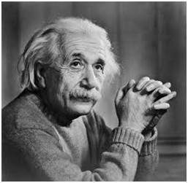

### North Direction Edges North West Direction Edges

